1. Reservation Management

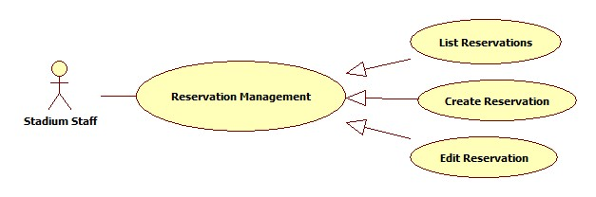

* 1. List Reservations

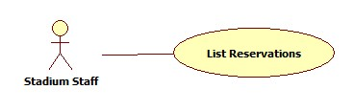

|  |  |  |  |  |
| --- | --- | --- | --- | --- |
| **USE CASE-n SPECIFICATION** | | | | |
| **Use-case No.** | <UC001> | **Use-case Version** | | <1.0> |
| **Use-case Name** | List Reservations | | | |
| **Author** | ThinhND | | | |
| **Date** | 12/02/2014 | **Priority** | High | |
| **Actor:**  Stadium Staff  **Summary:**  This use case describes listing reservations.  **Goal:**  List all reservations.  **Triggers:**  N/A  **Preconditions:**  Login as Stadium Staff role  **Post-conditions:**  N/A  **Main Success Scenario:**   |  |  |  | | --- | --- | --- | | Step | Actor Action | System Response | | 1 |  | The system shows list of reservation. |   **Alternative Scenario:**   |  |  | | --- | --- | | Actor Action | System Response | |  |  |   **Exceptions:**  N/A  **Relationships:**  N/A  **Business Rules:**  N/A | | | | |

* 1. Create Reservation

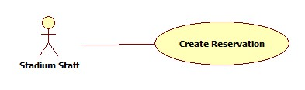

|  |  |  |  |  |
| --- | --- | --- | --- | --- |
| **USE CASE-n SPECIFICATION** | | | | |
| **Use-case No.** | <UC001> | **Use-case Version** | | <1.0> |
| **Use-case Name** | Create Reservation | | | |
| **Author** | ThinhND | | | |
| **Date** | 12/02/2014 | **Priority** | High | |
| **Actor:**  Stadium Staff  **Summary:**  This use case describes creating a reservation.  **Goal:**  Create a reservation.  **Triggers:**  Click Create button  **Preconditions:**  Login as Stadium Staff role  **Post-conditions:**  N/A  **Main Success Scenario:**   |  |  |  | | --- | --- | --- | | Step | Actor Action | System Response | | 1 | Click on Create button | Display Book form | | 2 | Enter information of booking  Click on Check available button | Show Field is available message | | 3 | Click OK button | Show successful message and save this reservation |   **Alternative Scenario:**   |  |  | | --- | --- | | Actor Action | System Response | | Click on Check available button | Show Field is not available message | | Click on Cancel button | Back to previous page |   **Exceptions:**  This field is not available such as existing reservation, duplicate booking time, etc.  **Relationships:**  N/A  **Business Rules:**  N/A | | | | |

* 1. Edit Reservation

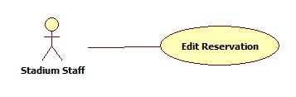

|  |  |  |  |  |
| --- | --- | --- | --- | --- |
| **USE CASE-n SPECIFICATION** | | | | |
| **Use-case No.** | <UC001> | **Use-case Version** | | <1.0> |
| **Use-case Name** | Edit Reservation | | | |
| **Author** | ThinhND | | | |
| **Date** | 12/02/2014 | **Priority** | High | |
| **Actor:**  Stadium Staff  **Summary:**  This use case describes editing a reservation.  **Goal:**  Edit reservation’s information.  **Triggers:**  Click the Reservation which will be edited  **Preconditions:**  Login as Stadium Staff role  **Post-conditions:**  N/A  **Main Success Scenario:**   |  |  |  | | --- | --- | --- | | Step | Actor Action | System Response | | 1 | Click on Reservation which will be edited | Display this Reservation’s information | | 2 | Enter new reservation information Click Check Available button | Show Field is available message | | 3 | Click Save button | Show successful message and save this reservation |   **Alternative Scenario:**   |  |  | | --- | --- | | Actor Action | System Response | | Click on Check available button | Show Field is not available message | | Click on Cancel button | Show confirm cancelation message  Discard all recent filled information and back to previous page |   **Exceptions:**  This field is not available such as existing reservation, duplicate booking time, etc.  **Relationships:**  N/A  **Business Rules:**  N/A | | | | |

1. Stadium promotion management

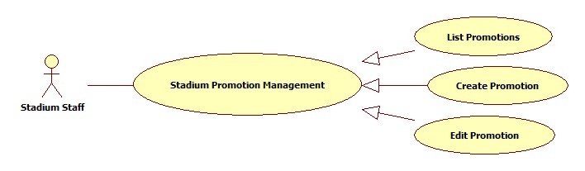

* 1. List Promotions

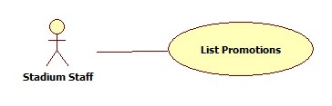

|  |  |  |  |  |
| --- | --- | --- | --- | --- |
| **USE CASE-n SPECIFICATION** | | | | |
| **Use-case No.** | <UC001> | **Use-case Version** | | <1.0> |
| **Use-case Name** | List Promotions | | | |
| **Author** | ThinhND | | | |
| **Date** | 12/02/2014 | **Priority** | High | |
| **Actor:**  Stadium Staff  **Summary:**  This use case describe listing Promotions  **Goal:**  List all Promotions of stadium  **Triggers:**  N/A  **Preconditions:**  Login as Stadium Staff role  **Post-conditions:**    **Main Success Scenario:**   |  |  |  | | --- | --- | --- | | Step | Actor Action | System Response | | 1 |  | The system shows list of reservation. |   **Alternative Scenario:**     |  |  | | --- | --- | | Actor Action | System Response | |  |  |   **Exceptions:**  N/A  **Relationships:**  N/A  **Business Rules:**  N/A | | | | |

* 1. Create Promotion

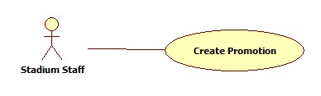

|  |  |  |  |  |
| --- | --- | --- | --- | --- |
| **USE CASE-n SPECIFICATION** | | | | |
| **Use-case No.** | <UC001> | **Use-case Version** | | <1.0> |
| **Use-case Name** | Create Promotion | | | |
| **Author** | ThinhND | | | |
| **Date** | 12/02/2014 | **Priority** | High | |
| **Actor:**  Stadium Staff  **Summary:**  This use case describes creating a Promotion.  **Goal:**  Create a Promotion for stadium.  **Triggers:**  Click Create button  **Preconditions:**  Login as Stadium Staff role  **Post-conditions:**  N/A  **Main Success Scenario:**   |  |  |  | | --- | --- | --- | | Step | Actor Action | System Response | | 1 | Click on Create button | Display Promotion form | | 2 | Enter information of Promotion Click OK button | Show successful message and save this Promotion |   **Alternative Scenario:**   |  |  | | --- | --- | | Actor Action | System Response | | Click on Cancel button | Show cancelation confirm message and back to previous page |   **Exceptions:**  N/A  **Relationships:**  N/A  **Business Rules:**  N/A | | | | |

* 1. Edit Promotion

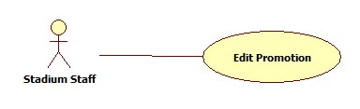

|  |  |  |  |  |
| --- | --- | --- | --- | --- |
| **USE CASE-n SPECIFICATION** | | | | |
| **Use-case No.** | <UC001> | **Use-case Version** | | <1.0> |
| **Use-case Name** | Edit Promotion | | | |
| **Author** | ThinhND | | | |
| **Date** | 12/02/2014 | **Priority** | High | |
| **Actor:**  Stadium Staff  **Summary:**  This use case describes editing a promotion.  **Goal:**  Edit reservation’s information.  **Triggers:**  Click the promotion which will be edited  **Preconditions:**  Login as Stadium Staff role  **Post-conditions:**  N/A  **Main Success Scenario:**   |  |  |  | | --- | --- | --- | | Step | Actor Action | System Response | | 1 | Click on Promotion which will be edited | Display this Reservation’s information | | 2 | Enter new Promotion information Click Save button | Show successful message and save this reservation |   **Alternative Scenario:**   |  |  | | --- | --- | | Actor Action | System Response | | Click on Cancel button | Show confirm cancelation message  Discard all recent filled information and back to previous page |   **Exceptions:**  N/A  **Relationships:**  N/A  **Business Rules:**  N/A | | | | |